# Getting Started: CSUN 2014 Hackathon - Open-A11y-Testing (using Git and GitHub)

Hackathon, Saturday, March 22, 2014.
Annual International Technology for Persons with Disabilities Conference.

## Intro

John Foliot came up with the idea for this Hackathon to test HTML5+ARIA support (in browser/AT/OS +versions) at CSUN where a rich pool of developers and testers/users might be expected to congregate. Karl Groves set up our GitHub presence (Open-A11y-Testing) including the repository, test files, and support files to get us started.

The idea is (for each dev participant) to create a test file that will test a *single* concept (say, the aria-hidden attribute). Some will create test files, while others will complete a form and run the test files in the configurations (browser/AT/OS) they have on their devices (laptop, mobile), and record the results. To help in this effort you can be a developer, a tester/user, or both.



## Git and GitHub (for Dummies)

### Developers

To create test files and add them to the repository, you need two things:

1. **Git** (local: versioning application you download to your computer)
2. **GitHub** (remote: is an on-line workspace that works with Git)
   1. You can store and access your work online, on GitHub, but only if you EXPLICITLY SEND IT THERE - via a Git ***push***
   2. What you do locally on your computer (in Git) doesn’t appear remotely online (in GitHub); until you create the pathways and make the explicit commands

Tester/Users  
To run those test files all you need to do is open the files on your device, and record your results in the form…….??

### Developer Steps for those without a GitHub Account

Please follow these steps in this order:

1. Quickly read about these terms (Blame, Branch, Clone, Commit, Fork, Merge, Pull Request, Push, Repository) in the [GitHub Glossary](https://help.github.com/articles/github-glossary)
2. GitHub: Go to <https://github.com/> and sign-up for a new GitHub account (It is Free)

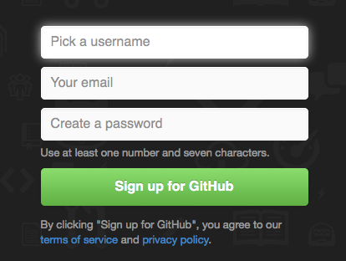

1. Git: Download the app for [Windows](https://windows.github.com/), or for [Mac](https://mac.github.com/), or [Linux and/or Unix](http://git-scm.com/download/linux) (each Free)
2. After install, open the downloaded app
3. Log-in to the local app, the login should look something like this:  
   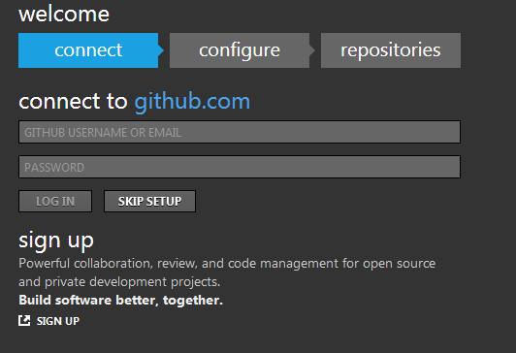
4. Enter your GitHub login details (you created in Step #2) using the **email address** and password.  
   (If you use your username instead of the email address, things could get screwy)
5. Once you are back at the main screen you should see the repositories (Repos) that are available for you to Clone. On the left, you'll see your GitHub account, as well as any organizations you're a part of. Clicking on a name will show you which repositories are available.
6. Click the **Clone** button. (Clicking on **Clone** brings the repository to your computer.)
7. Now open up your Documents folder and you should see a new folder called GitHub, in there will be your cloned Repo. You now have a local copy of your GitHub repository.
8. Read our [Contributing](https://github.com/Open-A11y-Testing/Test-Triage/blob/master/contributing.md) document (to learn how to create and structure the test files)
9. Fork the Repo ([Open-A11y-Testing /Test-Triage](https://github.com/Open-A11y-Testing/Test-Triage/blob/master/contributing.md)), by clicking the "Fork" button in the GitHub.com repository.  
   Represents the Pull Request, Watch, Star and Fork buttons
10. Get the [Git Cheat Sheet](https://github.com/github/training-materials/blob/master/downloads/github-git-cheat-sheet.pdf?raw=true) (if using command line)
11. Validate your HTML, CSS and JavaScript

??

### Developer Steps for those with a GitHub Account

Please follow these steps in this order:

1. ??
2. ??
3. ??

### Tester/User Steps

Registration  
Upon first page view, the system checks for the existence of our cookie, indicating that the user has been here before. (it checks cookie value *and* looks for a corresponding record in the users table)

If no match is found we redirect the user to a registration page at which they enter the following information:  
 * browserBrand  
 * browserVersion  
 * operatingSystem  
 * osVersion  
 * uaString  
 * atType  
 * atBrand  
 * atVersion

Upon successful submission of the form, we enter a new record in the users table and set a cookie with their userKey value.

Testing

Upon successful submission of the registration form (or on subsequent visits where we see a valid cookie) users can then begin testing.

* User accesses the test page and is presented with a test file (retrieved at random). They can skip (and be presented with another file at random) or stay

* Each test file is intended to present a single concept and has an accompanying description of what is being tested. The user interacts with the test file.

* The user then fills in a form to indicate whether or not the test was a pass or fail and, optionally, what happened instead.

* User submits the form and, upon successful submission, will be presented with another random test file.

??

## Open-A11y-Testing URLs

Contributing Doc: <https://github.com/Open-A11y-Testing/Test-Triage/blob/master/contributing.md>

Repo (Repository): <https://github.com/Open-A11y-Testing/Test-Triage>

Issues: <https://github.com/Open-A11y-Testing/Test-Triage/issues>

## Resources

John Foliot’s Hackathon Blog: <http://john.foliot.ca/csun-2014-hackathon/>   
YouTube Video: GitHub for Beginners: <https://www.youtube.com/watch?v=LXoWxrTdXkM>  
GitHub Glossary: <https://help.github.com/articles/github-glossary>  
GitHub Common Issues:

## Help

For assistance with using Git and/or GitHub grab Katie Haritos-Shea, ?? or ??.   
For assistance with the repository organization, structure and class names, and file naming conventions grab Karl Groves and ?? (Steven Faulkner?).  
For assistance with ideas for tests and useful next steps grab John Foliot.

Note 1: Forms are presented & validated by PHP. Contact [karl@karlgroves.com](mailto:karl@karlgroves.com) for structure and class names  
Note 2: UI is presented using PHP templates. Contact [karl@karlgroves.com](mailto:karl@karlgroves.com) for structure and class names